Marmara Üniversitesi
Mühendislik Fakültesi
Elektrik-Elektronik Mühendisliği

Laboratory Manual

EE 3011
Electronics I

Experiment (3)
The Common-source Amplifier

Spring 2023
Experiment (3)
The Common-source Amplifier

Objectives
- To study the operation of a common-source amplifier.
- To verify the voltage gain relations of the common-source amplifier.

Pre-lab Work
Find general expressions for the voltage gain, input resistance and output resistance of the commonsource amplifier circuit in figure 1.
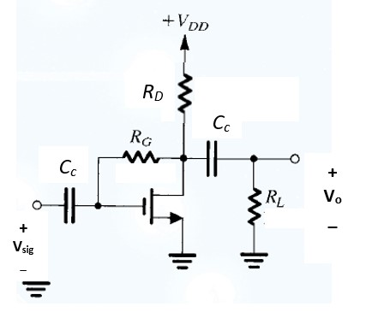

𝑣
!
"#

𝑣
$

Solution

Figure 1: A Common-source Amplifier Circuit.

Equipment
Table 1. Equipment for experiment 7.

 | Equipment | Model | Serial No. | S No.
1 | BreadBoard Station
2 | Resistors 10 kW (2), 100 kW (1), 1 MW (1)
3 | NMOS transistor (1) | 2N7000 | https://www.onsemi.com/pub/Collateral/2N7000-D.PDF
4 | Capacitors 22 µF (2)
5 | Multi-meter (1)
6 | Probes and cables

Experimental Procedure
Part (1): Amplifier Voltage Gain.
- Connect the circuit in figure 1 without the ac source, capacitors and the load resistor. Take 𝑉_{DD}=10 V, 𝑅_{D}=10 k and 𝑅_{G}=1 M.
- Measure the DC voltages at the drain and at the gate. Measure the voltage across 𝑅! to find the DC drain current .Make sure the transistor is operating in saturation mode.
- Now add the capacitors and the load resistor (𝑅_{L}=10 k) and connect a sinusoidal ac source 𝑣_{sig} . Start with a small amplitude (in mV) at 10 kHz for 𝑣_{sig}.
- Connect both the input signal and the output terminals to the oscilloscope using two channels.
- Observe both waveforms simultaneously and produce a sketch using graph 1.
- Increase the amplitude of 𝑣_{sig} in steps of 10 mV. In each case record the amplitudes of 𝑣_{sig} and 𝑣₀ in table 2.
- Continue until you notice that the output becomes distorted. Mark the maximum input and output before distortion.
Part (2): Input and Output Resistance of Amplifier.

- Reconsider the circuit in figure 1. Set the input signal at a comfortable value within the linear range of the amplifier.
- To find the output resistance of the amplifier, measure the voltage gain with and without the load resistor. Record results in table 3.
- To find the input resistance, connect a resistor (𝑅_{x}=100 kW) between the input voltage source and the coupling capacitor (in series). Measure the voltage gain with and without 𝑅_{x}. Record results in table 3.

Results and Analysis
Part (1): Amplifier Voltage Gain.

- Calculate the voltage gain of this amplifier (𝑣₎/𝑣_{&’(}) and record your results in table 2.
- Comment on the linearity of the amplifier in this circuit.
Answer:
The gain decreases by 4 for every 10 mV increase in input voltage. This suggests that the amplifier's response is not linear.

In a linear amplifier, the output should ideally change in direct proportion to the input, maintaining a constant gain. In your case, the decrease in gain for each step of 10 mV indicates a non-linear relationship between the input and output.

The linearity of an amplifier refers to its ability to faithfully reproduce the input signal without distortion. In your scenario, the decreasing gain suggests that the amplifier's response is non-linear, which can result in distortion or alteration of the output waveform compared to the input.

- What is the maximum output swing for this set-up of the amplifier? Explain.
Answer: Maximum output voltage 4.13V.
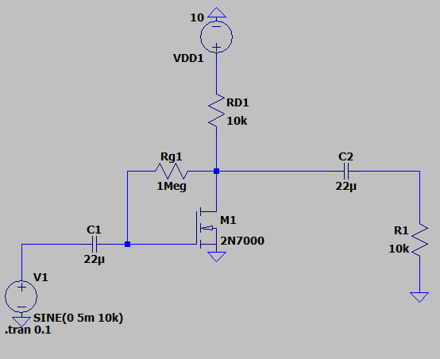
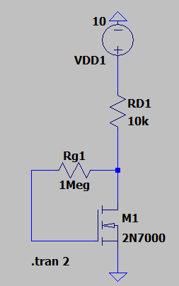

First Part of The Circuit (Circuit 1) Last Part of The Circuit (Circuit 2)
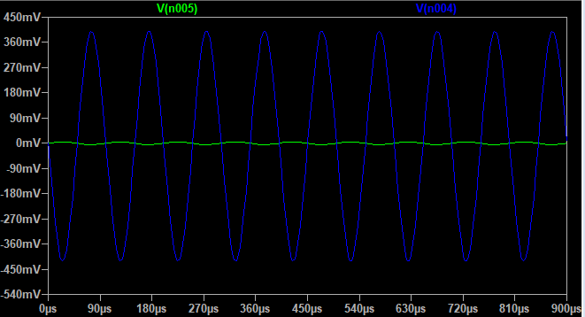

Graph 1: Amplifier input/output waveforms. (Circuit 2)

Table 2. Voltage Gain Results (Circuit 2)
 | Amplitudes
𝑣_{sig}(mV) | 𝑣_{o} (mV) | Gain
5 | 400 | 80
15 | 1140 | 76
25 | 1802 | 72,08
35 | 2376 | 67,89
45 | 2870 | 63,78
55 | 3290 | 59,82
65 | 3629 | 55,83
75 | 3870 | 51,6
85 | 4034 | 47,459
95 | 4120 | 43,368
 | Amplitudes
𝑣_{sig}(mV) | 𝑣_{o} (mV) | Gain
100 | 4130 | 41,3
150 | 4130 | 27,53
350 | 4130 | 11,8
… | … | …
… | … | …
… | … | …

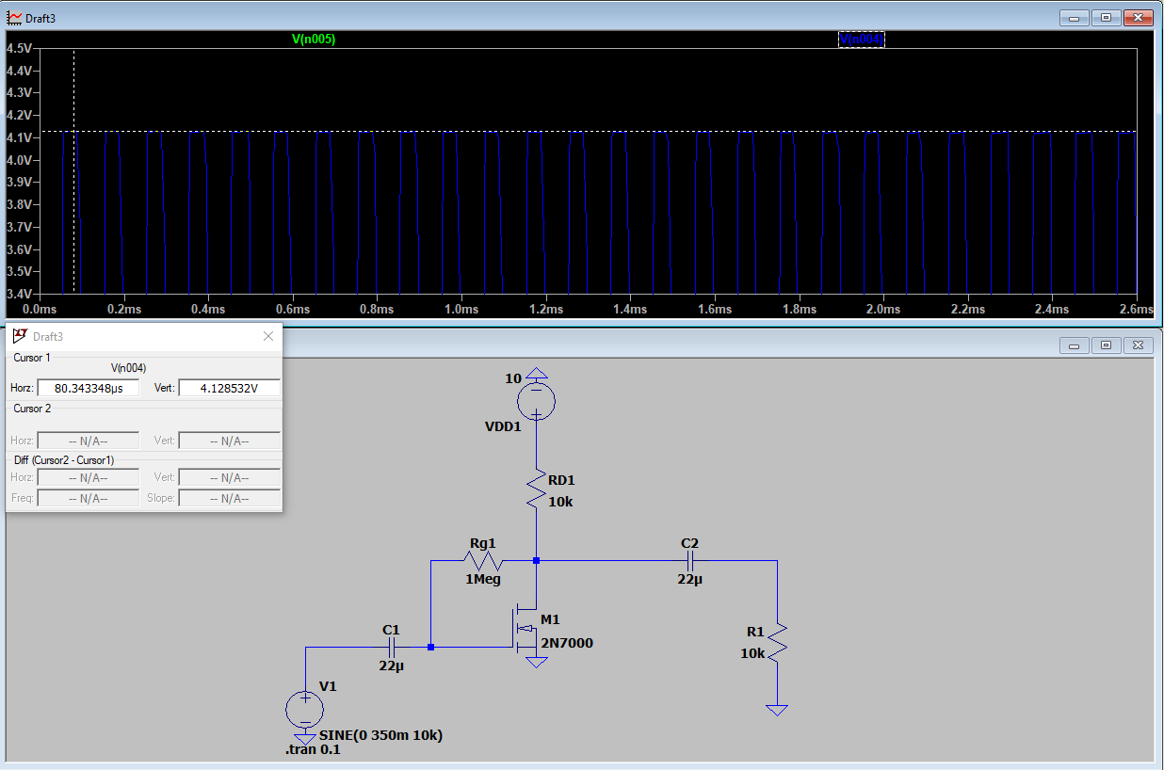

Part (2): Input and Output Resistance of Amplifier.

- Calculate the input and output resistances of this amplifier circuit and record them in table 3.

Table 3. Input/output Resistances.

Output Resistance (k) |  |  | Input Resistance (k)
Gain with 𝑅_{L} | Gain without 𝑅_{L} | 𝑅₀ | Gain with 𝑅_{x} | Gain without 𝑅_{x} | 𝑅_{i}

- Comment on your results based on your knowledge of the properties of the common-source amplifier.
Answer:

Name | Yunus Emre Turunç
ID | 150721854
Section | Online

